SIMATS ENGINEERING

ASSESSMENT TOOL 2

COURSE NAME: Database Management Systems COURSE CODE: CSA05

NAME: M.NITHYASHREENARAYANI

REG.NO: 192521416

COURSE OUTCOME COVERED

CO1: Analyze DBMS architecture, different data models, schema types, and design ER/EER diagrams, relational schemas for case-based scenarios by identifying entities and relationships. (BL1, BL2)

Activity Tool : Concept Mapping (Medium) Assessment Tool Weightage: 35%

Dr

QUESTIONS |  | Total Marks: 50
Q.No | Question | Bloom's Level | Marks
1 | Construct a concept map linking the following terms: DBMS, Schema, Instance, Data Model, ER Diagram, Entity, Attribute, Relationship. | BL2 – Understand | 5
2 | Create a concept map for the three-level ANSI/SPARC architecture showing data independence at each level. | BL2 – Understand | 5
3 | Map the relationship between file-based systems and database systems, highlighting the problems solved by DBMS. | BL2 – Understand | 5
4 | Design a concept map for ER diagram components: entity, weak entity, attribute types, relationship types, and participation constraints. | BL2 – Understand | 5
5 | Construct a concept map comparing Hierarchical, Network, and Relational data models with their key properties. | BL2 – Understand | 5
6 | Develop a concept map for the EER model showing how it extends the basic ER model with generalization, specialization, and aggregation. | BL2 – Understand | 5
7 | Create a visual concept map for the DBMS software architecture, | BL2 – Understand | 5

 | illustrating the flow from user request to data retrieval.
8 | Map the data models discussed in CO1 to real-world applications and explain the suitability of each model. | BL2 – Understand | 5
9 | Construct a concept map for schemas and instances, showing how they relate to physical and logical data independence. | BL2 – Understand | 5
10 | Design a concept map for the roles and responsibilities in a DBMS environment: DBA, End User, Application Developer. | BL1 – Remember | 5

Code of Conduct:

I M.NITHYASHREENARAYANI / 192521416(Name / Reg No) certify that this submission is my original work and that I have adhered to the guidelines specified for this assessment.
I understand that any violation of academic integrity rules will result in disciplinary action.
Signature of the student:


RUBRICS FOR CALCULATION:

Criteria | Weightage | Level 4 (Exemplary) | Level 3 (Proficient) | Level 2 (Developing) | Level 1 (Beginning)
Concept Identification | 25% | Identifies all key concepts from literature accurately and comprehensively | Identifies most key concepts with minor omissions | Identifies limited concepts; some are irrelevant or missing | Fails to identify essential concepts
Linkages | 25% | Establishes clear, meaningful, and accurate relationships between concepts | Shows correct relationships with minor gaps | Relationships are weak, unclear, or partially incorrect | No meaningful relationships established
Organization | 20% | Concepts are well-structured hierarchically with logical flow and grouping | Mostly organized with minor structural issues | Some organization but lacks clear hierarchy | No logical organization or structure
Integration of Literature | 20% | Integrates multiple studies effectively to show | Shows some integration of literature | Limited integration; mostly isolated | No integration of literature evidence

 |  | connections and comparisons |  | concepts
Clarity | 10% | Concept map is clear, neat, visually structured, and easy to interpret | Generally clear with minor readability issues | Clarity is reduced; difficult to interpret in parts | Poorly presented and hard to understand

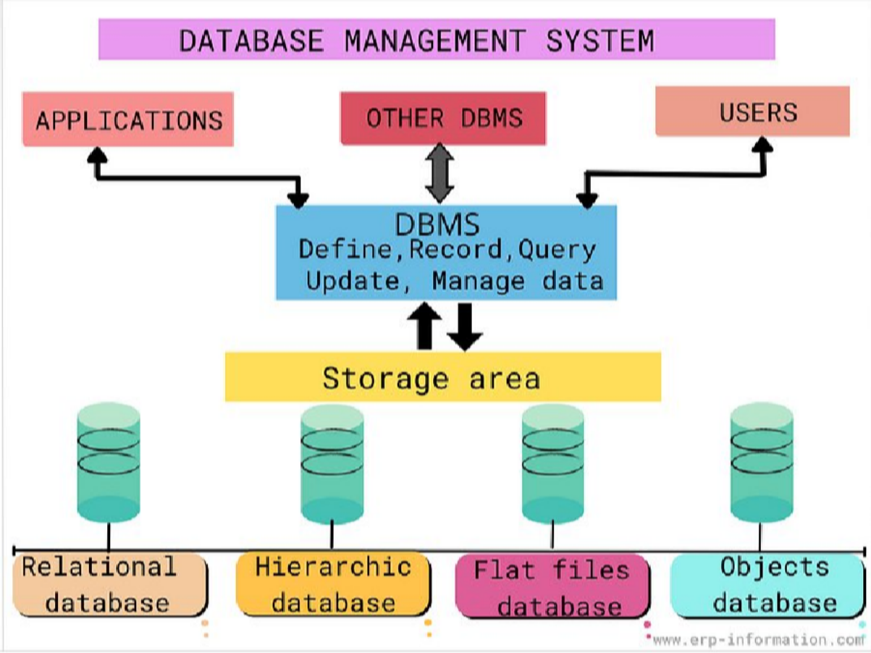

Q1. Concept map linking DBMS, Schema, Instance, Data Model, ER Diagram, Entity, Attribute, Relationship
Bloom's Level: BL2 – Understand | Marks: 5

Concept Map
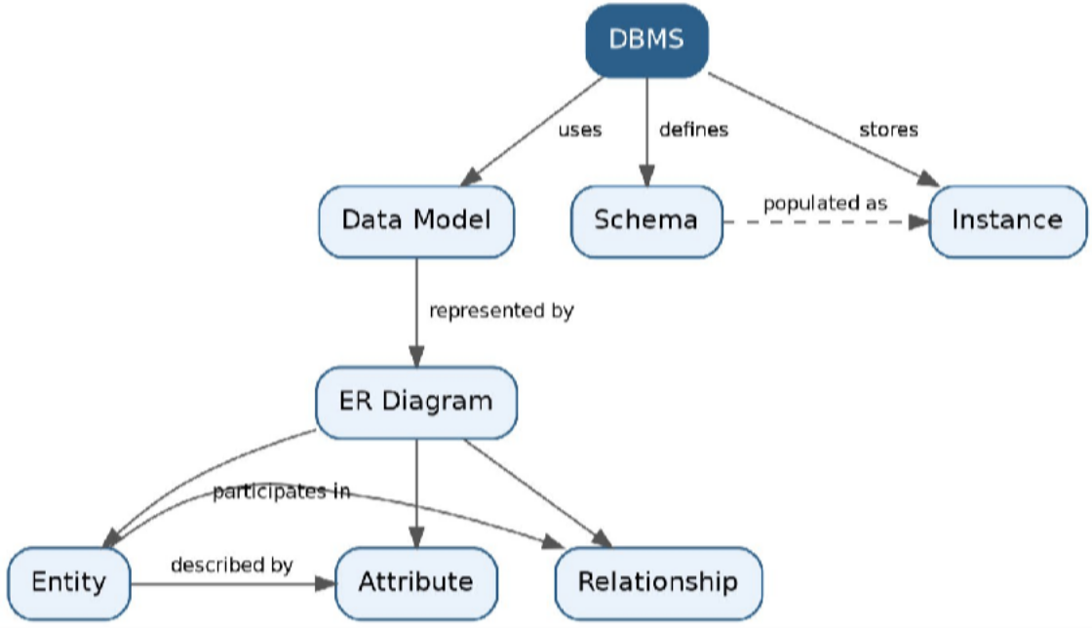

Theory
A DBMS (Database Management System) is software that uses an underlying Data Model to define how data is organized. This organization is expressed as a Schema — the fixed structural description of the database (tables, fields, constraints) — while an Instance is the actual data stored at a given moment, which keeps changing as records are inserted, updated, or deleted.
The Data Model is commonly represented visually through an ER Diagram (Entity-Relationship Diagram). An ER Diagram depicts three core building blocks: an Entity (a real-world object such as STUDENT or COURSE), its Attributes (properties describing the entity, e.g., Name, Roll_No), and Relationships (associations between two or more entities, e.g., STUDENT enrolls in COURSE).

Key Terms Table

Term | Definition
DBMS | Software system that enables creation, storage, retrieval, and management of data in databases.
Schema | The overall logical/physical design or blueprint of the database; changes rarely.
Instance | The actual data present in the database at a specific point in time; changes frequently.
Data Model | A conceptual set of tools/notations for describing data, relationships, and constraints (e.g., Relational, ER, Object-oriented).
ER Diagram | Graphical representation of entities, attributes, and relationships using the ER data model.
Entity | A real-world object or concept that can be distinctly identified (e.g., Employee, Product).
Attribute | A property or characteristic of an entity (e.g., Name, Age, Salary).
Relationship | An association among two or more entities (e.g., Works_For, Enrolls_In).

Q2. Concept map for the three-level ANSI/SPARC architecture showing data independence at each level
Bloom's Level: BL2 – Understand | Marks: 5

Concept Map
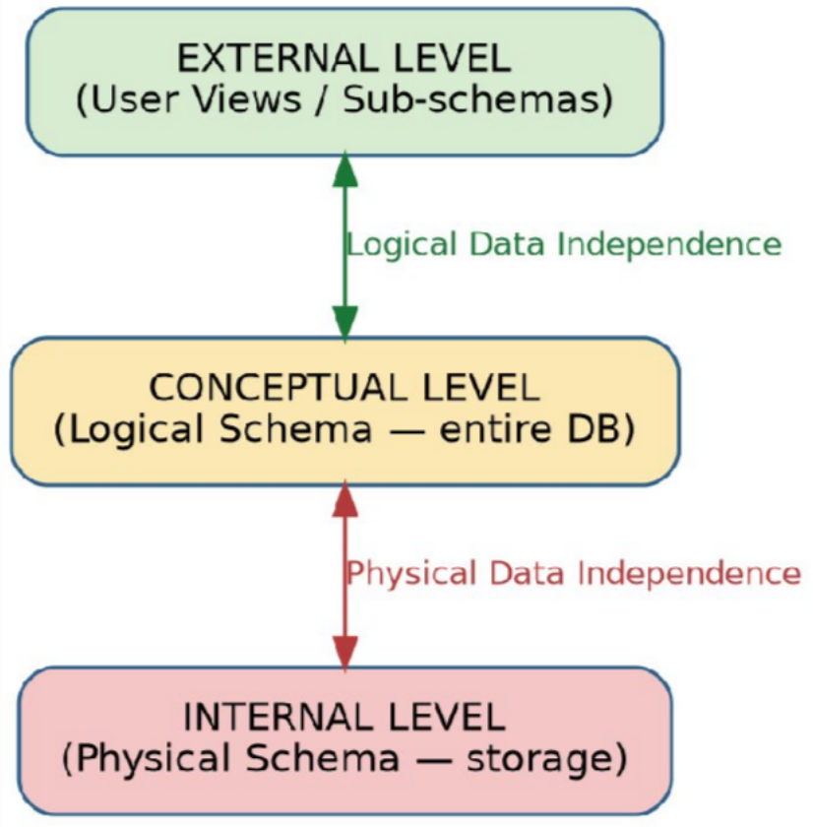

Theory
The ANSI/SPARC architecture divides a database system into three levels to separate what users see from how data is physically stored:
- External Level (View Level): Describes how individual users see their part of the database through views, tailored to each user group's needs.
- Conceptual Level (Logical Level): Describes the structure of the whole database for the community of users — entities, relationships, constraints — independent of storage details.
- Internal Level (Physical Level): Describes how data is actually stored on disk — file organization, indexing, access paths.
Two forms of data independence connect these levels:

Independence Type | Description
Logical Data Independence | Ability to change the conceptual schema without altering external schemas/application programs (between External and Conceptual levels).
Physical Data Independence | Ability to change the internal (physical/storage) schema without altering the conceptual schema (between Conceptual and Internal levels).

Q3. Relationship between file-based systems and database systems, highlighting problems solved by DBMS
Bloom's Level: BL2 – Understand | Marks: 5

Concept Map
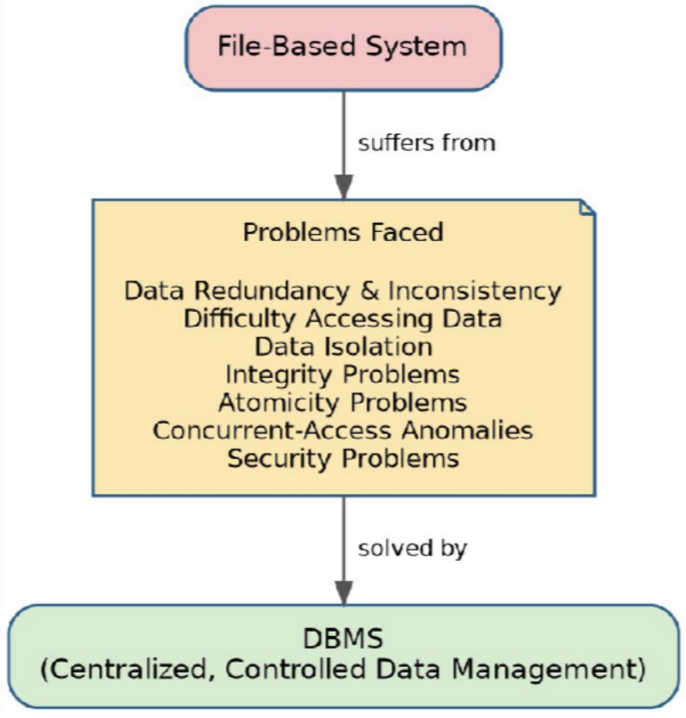

Theory
Before DBMS, organizations stored data in File-Based Systems where each application maintained its own separate files. This approach suffered from several drawbacks that the DBMS approach was designed to solve, by centralizing data and providing controlled, shared access.

Problem in File System | How DBMS Solves It | Example
Data Redundancy & Inconsistency | Centralized data storage; single copy of data | Student address stored once, not in every department's file
Difficulty in Accessing Data | Query languages (SQL) allow flexible retrieval | Ad-hoc queries without writing new programs
Data Isolation | Data integrated in one repository, accessible across programs | Common database for Library, Fees, Exam modules
Integrity Problems | Constraints (PK, FK, Check) enforced by DBMS | Age > 0 constraint enforced automatically
Atomicity Problems | Transaction management (ACID properties) | Bank transfer either fully completes or fully rolls back
Concurrent Access Anomalies | Concurrency control (locking, timestamps) | Two users updating same seat booking safely
Security Problems | Authorization and access control | Only HR can view salary data

Q4. Concept map for ER diagram components: entity, weak entity, attribute types, relationship types, participation constraints
Bloom's Level: BL2 – Understand | Marks: 5

Concept Map

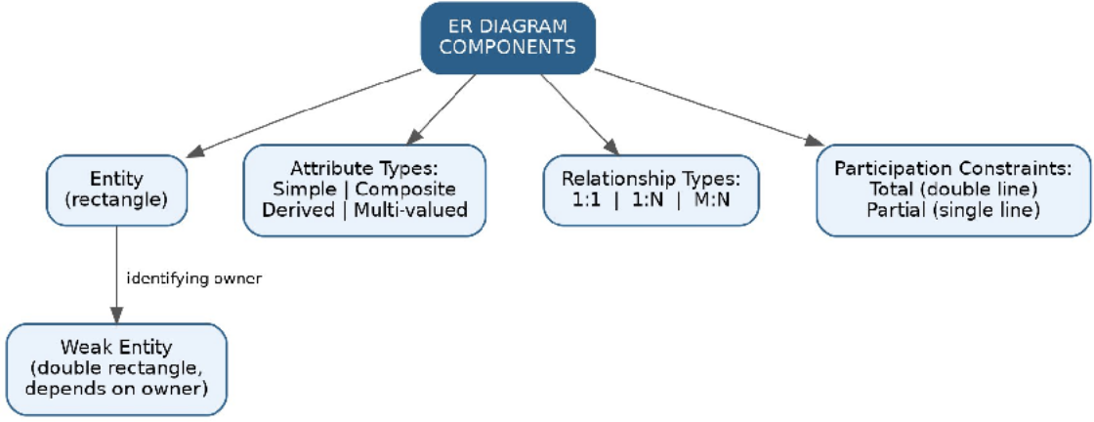

Theory
- Entity: A distinguishable real-world object, represented as a rectangle (e.g., EMPLOYEE).
- Weak Entity: An entity that cannot be uniquely identified by its own attributes alone and depends on an owner/identifying entity (e.g., DEPENDENT depends on EMPLOYEE); shown with a double rectangle.
- Attribute Types: Simple (atomic, e.g., Age), Composite (divisible, e.g., Name = First+Last), Derived (computed, e.g., Age from DOB), Multi-valued (multiple values, e.g., Phone_Numbers).
- Relationship Types: Classified by cardinality — 1:1, 1:N, M:N — describing how many instances of one entity relate to another.
- Participation Constraints: Total participation (every entity instance must participate, shown by double line) vs Partial participation (participation is optional, shown by single line).

Notation Summary Table

Component | Symbol | Example
Entity | Rectangle | STUDENT
Weak Entity | Double Rectangle | DEPENDENT
Attribute | Oval | Name, Age
Multi-valued Attribute | Double Oval | Phone_Numbers
Relationship | Diamond | ENROLLS_IN
Total Participation | Double Line | Every ORDER must have a CUSTOMER

Q5. Concept map comparing Hierarchical, Network, and Relational data models with key properties
Bloom's Level: BL2 – Understand | Marks: 5

Concept Map
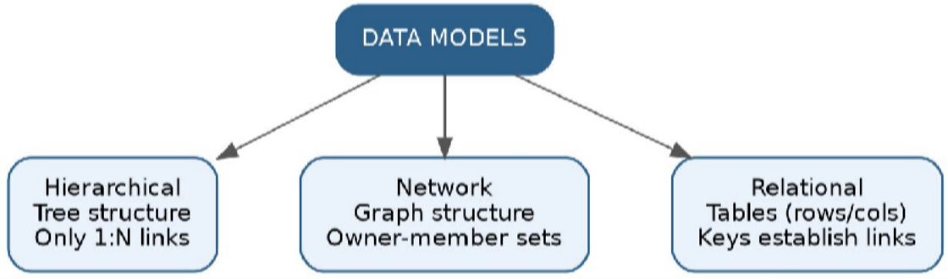

Theory

Early data models organized data using explicit navigational structures, while the relational model (introduced by E. F. Codd, 1970) organizes data into simple tables and lets users query using declarative languages like SQL.

Property | Hierarchical | Network | Relational
Structure | Tree (parent-child) | Graph (owner-member sets) | Tables (rows & columns)
Relationship Type | Only 1:N | 1:1, 1:N, M:N | 1:1, 1:N, M:N (via  keys)
Navigation | Top-down, rigid path | Multiple paths via pointers | Declarative (SQL), no navigation needed
Flexibility | Low | Moderate | High
Example System | IMS (IBM) | IDMS | Oracle, MySQL, PostgreSQL

Q6. Concept map for EER model: generalization, specialization, aggregation
Bloom's Level: BL2 – Understand | Marks: 5

Concept Map
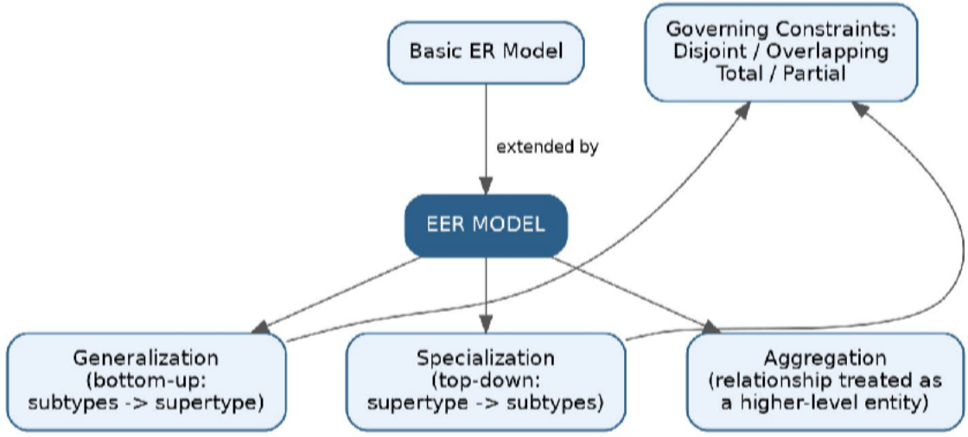

Theory
The Enhanced/Extended ER (EER) Model adds extra semantic constructs to the basic ER model to model complex applications more precisely:
- Generalization: A bottom-up process of combining several entity types that share common attributes into one higher-level generalized entity type (e.g., CAR and TRUCK generalized into VEHICLE).
- Specialization: A top-down process of defining subtypes (subclasses) of an entity type that have distinct attributes (e.g., EMPLOYEE specialized into ENGINEER and MANAGER).
- Aggregation: A concept where a relationship itself is treated as a higher-level entity so it can participate in another relationship (e.g., the relationship WORKS_ON between EMPLOYEE and PROJECT is aggregated so it can relate to MANAGER as its supervisor).
Both generalization and specialization are further governed by disjointness constraints (disjoint/overlapping) and completeness constraints (total/partial).

Q7. Visual concept map for DBMS software architecture, illustrating flow from user request to data retrieval
Bloom's Level: BL2 – Understand | Marks: 5

Concept Map
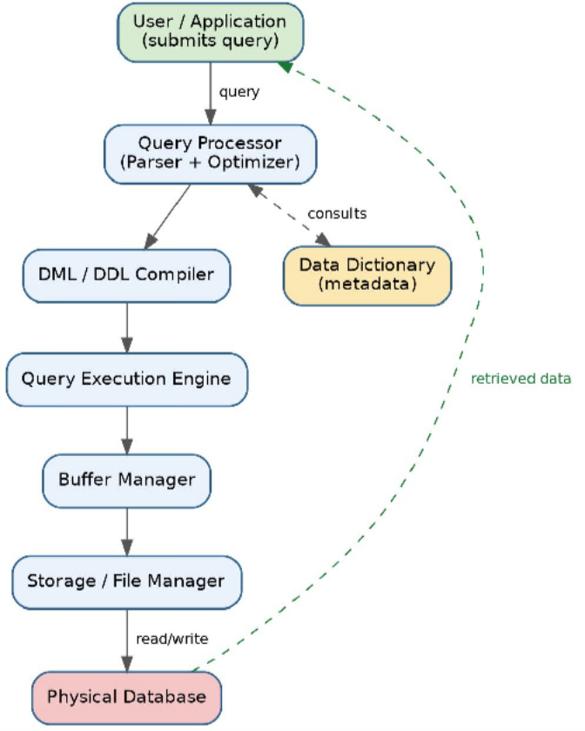

Theory
When a user or application submits a query, it passes through several DBMS components before data is returned:
- Query Processor: Parses the query for syntax and semantics, and the Optimizer chooses the most efficient execution plan.
- DML/DDL Compiler: Translates data manipulation or data definition statements into low-level instructions.
- Data Dictionary: Metadata repository consulted for schema information, constraints, and access rights.
- Query Execution Engine: Executes the optimized plan by invoking the storage manager.
- Buffer Manager: Manages the transfer of data between disk and main memory.
- Storage/File Manager: Interfaces with the operating system to read/write data blocks from the physical database on disk.
The result flows back up through the buffer manager and query processor to the user as a result set.

Q8. Map data models from CO1 to real-world applications and explain suitability of each model
Bloom's Level: BL2 – Understand | Marks: 5

Concept Map

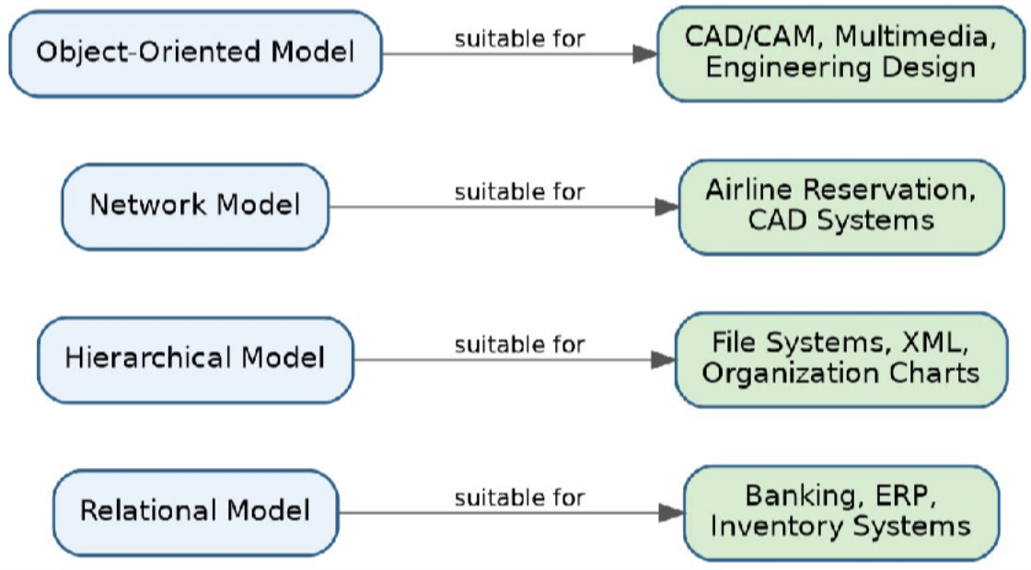

Theory / Suitability

Data Model | Real-World Application | Why Suitable
Relational Model | Banking, ERP, Inventory Management | Simple tabular structure, strong integrity/consistency support, mature SQL tooling for transactional systems.
Hierarchical Model | File systems, XML documents, Org charts | Naturally represents strict parent-child, one-to-many hierarchies.
Network Model | Airline reservation systems, CAD systems | Handles complex many-to-many relationships via owner-member sets efficiently.
Object-Oriented Model | CAD/CAM, multimedia databases, engineering design | Supports complex objects, inheritance, and encapsulation needed for rich data types.

Q9. Concept map for schemas and instances, showing relation to physical and logical data independence
Bloom's Level: BL2 – Understand | Marks: 5

Concept Map
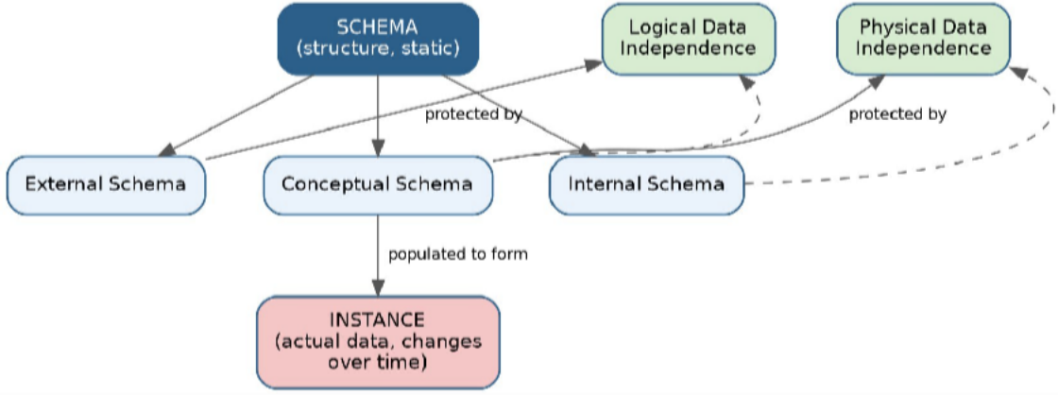

Theory
A Schema is the overall design/blueprint of the database and is largely static; it exists at three sub-levels — External, Conceptual, and Internal — corresponding to the ANSI/SPARC architecture. An Instance is the actual set of data (a snapshot) held in the database at a given moment, and it changes continuously as transactions occur, even though the schema stays constant.
Data independence is the capacity to modify a schema at one level without requiring changes to the schema at the next higher level:

Concept | Explanation
Logical Data Independence | Changes to the Conceptual Schema (e.g., adding a new attribute) do not require changing External Schemas or application programs.
Physical Data Independence | Changes to the Internal Schema (e.g., changing file organization, adding an index) do not require changing the Conceptual Schema.

Q10. Concept map for roles and responsibilities in a DBMS environment: DBA, End User, Application Developer
Bloom's Level: BL1 – Remember | Marks: 5

Concept Map
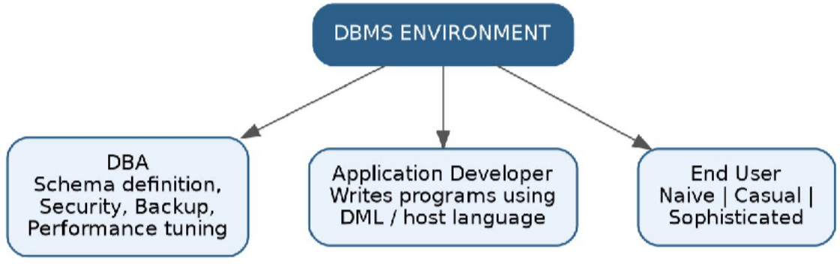

Theory

Role | Responsibilities
Database Administrator (DBA) | Schema definition and modification, granting authorization/access control, defining storage structure & access methods, routine maintenance, backup & recovery, monitoring performance.
Application Developer / Programmer | Writes application programs in host languages combined with DML (embedded SQL, APIs) to interact with the database and satisfy business requirements.
End User | Interacts with the database through queries or application interfaces without technical DBMS knowledge; classified as: Naive Users (use fixed menu-driven applications), Casual Users (occasionally query using SQL), and Sophisticated Users (write complex queries/analytics).

